**Design Patterns and Principles (Mandatory hands-on)**

**Exercise 1: Implementing the Singleton Pattern**

**CODE:**

public class SingletonPatternExample{

static class Logger {

private static Logger si;

private Logger() {

System.out.println("Logger instance created");

}

public static Logger getInstance() {

if (si== null) {

si=new Logger();

}

return si;

}

public void log(String m) {

System.out.println("Log: " + m);

}

}

public static void main(String[] args) {

Logger l1=Logger.getInstance();

Logger l2=Logger.getInstance();

l1.log("Message from logger1");

l2.log("Message from logger2");

if (l1==l2) {

System.out.println("Only one instance of Logger exists.");

} else {

System.out.println("Multiple instances exist! Singleton failed.");

}}}

**OUTPUT:**

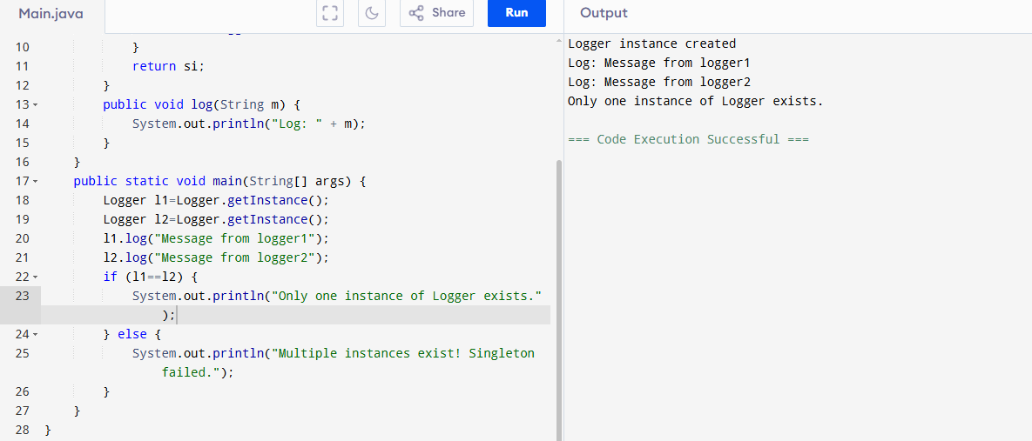

**Exercise 2: Implementing the Factory Method Pattern**

**CODE:**

public class FactoryExample {

interface document {

void open();

}

static class worddocument implements document {

public void open() {

System.out.println("Opening a Word document...");

}

}

static class pdfdocument implements document {

public void open() {

System.out.println("Opening a PDF document...");

}

}

static class exceldocument implements document {

public void open() {

System.out.println("Opening an Excel document...");

}

}

static abstract class documentfactory {

public abstract document createdocument();

}

static class wordfactory extends documentfactory {

public document createdocument() {

return new worddocument ();

}

}

static class pdffactory extends documentfactory {

public document createdocument() {

return new pdfdocument ();

}

}

static class excelfactory extends documentfactory {

public document createdocument() {

return new exceldocument ();

}

}

public static void main(String[] args) {

documentfactory wordfactory = new wordfactory();

document word= wordfactory.createdocument();

word.open();

documentfactory pdfFactory = new pdffactory();

document pdf= pdfFactory.createdocument();

pdf.open();

documentfactory excelfactory = new excelfactory();

document excel= excelfactory.createdocument();

excel.open();}}

**OUTPUT:**

